**Faculty/ Teacher Evaluation Form 2017**

**ANALYSIS REPORT**

The Faculty Evaluations of 138 Faculty Members were conducted in 11 Departments in hard-copy proformae. The questions and their short Forms are tabulated below:

Qshort Questions

1 FACEV05 The Teacher provides the Lecture schedule on the very first lecture

2 FACEV06 The Teacher provides the Lecture outlines before delivering the lecture

3 FACEV07 The Teacher is prepared for each class

4 FACEV08 The Teacher demonstrates knowledge of the subject

5 FACEV09 The Teacher has completed the whole course

6 FACEV10 The Teacher provides additional material apart from the textbook

7 FACEV11 The Teacher gives citations regarding current situations with reference to Pakistani context.

8 FACEV12 The Teacher communicates the subject matter effectively

9 FACEV13 The Teacher shows respect towards students and encourages class participation

10 FACEV14 The Teacher maintains an environment that is conducive to learning

11 FACEV15 The Teacher arrives on time

12 FACEV16 The Teacher leaves on time

13 FACEV17 The Teacher is fair in examination

14 FACEV18 The Teacher returns the graded scripts etc. in a reasonable amount of time

15 FACEV19 The Teacher was available during the specified office hours and for after class consultations

The detailed Faculty-wise Analysis is attached in separate PDF files for each department. In the summary below of Questionnaires of these departments heat plot is shown with 1-5 Likert-scale rating with 5 denoting “Strongly Agree”:

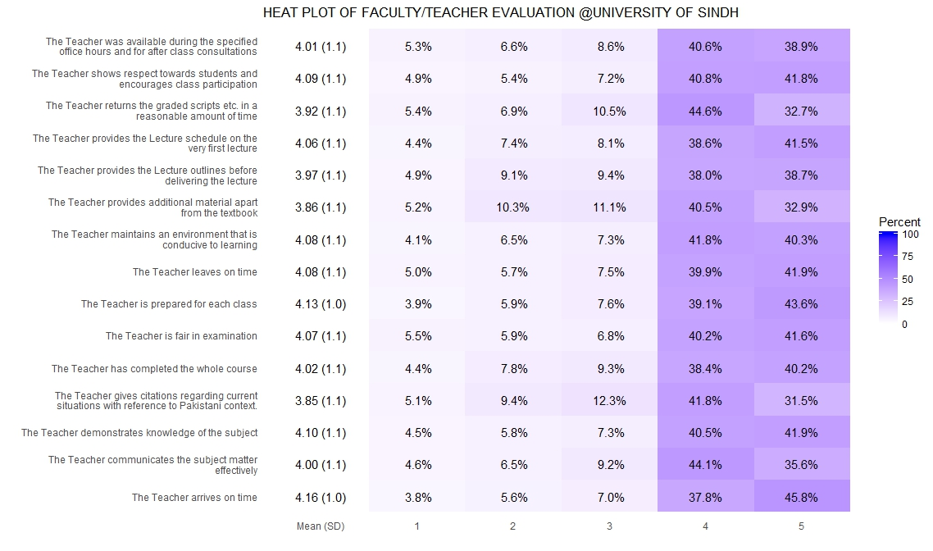

However, various departments differed in their students’ satisfaction and based on the mean values of every question from all departmental students, boxplots have been devised which are then sorted based on their medians as below:

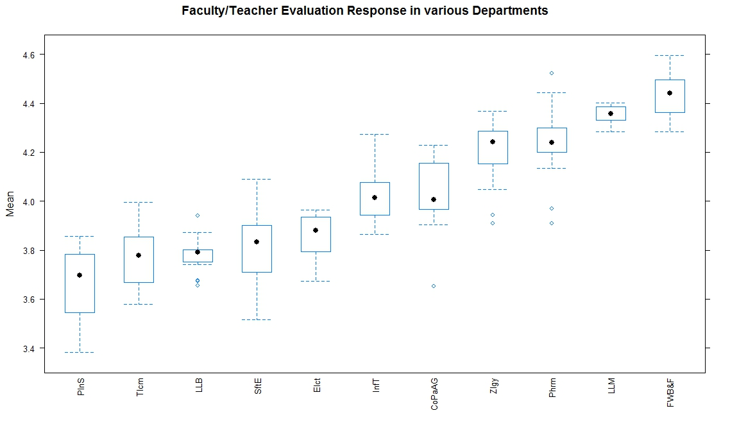

It is observed that in boxplots for LLB and LLM the variance is the least of all other departments, which strengthens the evaluation results most for these two programs. It is however, not clear why some departments show low mean responses from their students, therefore, questionnaire-wise plots have been devised to distinguish students’ responses as below:

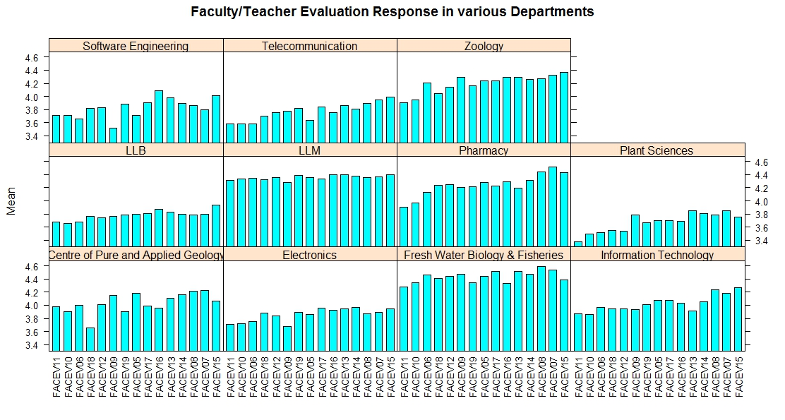

Its observed in above plot that except LLM and Fresh Water Biology the responses vary more by question to question in all other departments. It is also observed that questions FACEV10 and FACEV11 show least mean-values in some departments. The correlation of all questions has been calculated and the results have been prepared to show in the correlogram below:

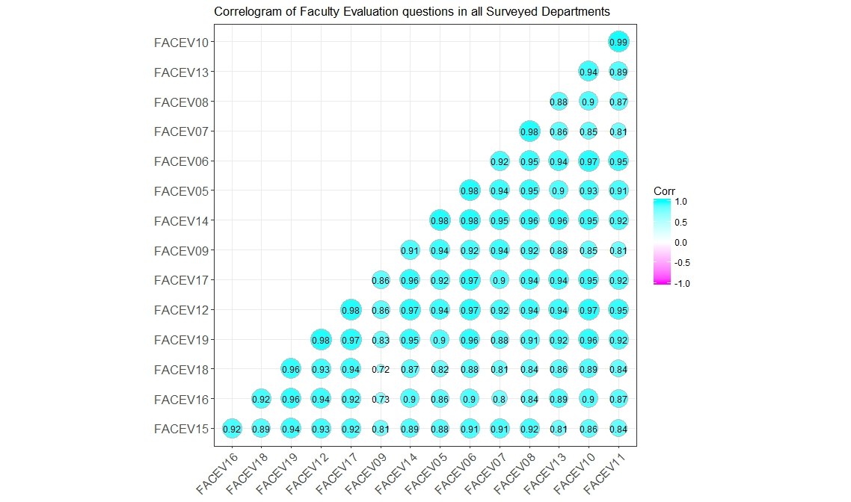

It is observed in above plot that lowest correlation 0.72 (however, its not weak) is between questions FACEV09 and FACEV18. The second least correlation 0.73 is between questions FACEV09 and FACEV16. The pair of these two questions again stated below for consideration.

5 FACEV09 The Teacher has completed the whole course

14 FACEV18 The Teacher returns the graded scripts etc. in a reasonable amount of time

5 FACEV09 The Teacher has completed the whole course

12 FACEV16 The Teacher leaves on time

The questionnaire-wise stacked bar plot was also devised to distinguish various questionnaire responses further as below:

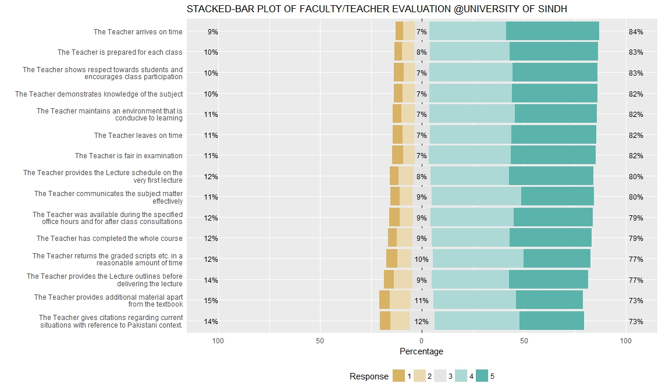

The above plot shows that 84% responses are in favour for the question “The Teacher arrives on Time”, while 79% responses in favour of the question “The Teacher has completed the whole course”. But the correlation tells that there is 2nd least correlation (as compared among other correlations) between “Teacher has completed the whole course” and “Teacher leaves on Time”. So leaving on time doesn’t very strongly correlate with course completion.

The above plots may be further referred for exploring more details.

Moreover, Faculty Evaluation Survey, in all programs and classes, were sent through Google Forms to emails of all University enrolled students. The students responded randomly from various departments of University of Sindh. The overall mean value on Likert-scale 1-5 was 4.14.

*Radar Chart showing various mean values received from various departments*

*–Data: from Google Forms Survey in all Departments*